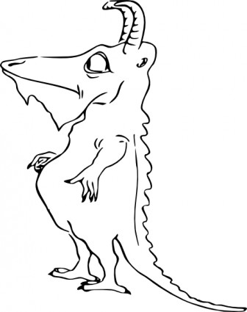
Design a Predator Rubric

CATEGORY | 4 | 3 | 2 | 1
Drawing - details | All assigned details have been added. The details are clear and easy to identify. | Almost all assigned details (at least 85%) have been added. The details are clear and easy to identify. | Almost all assigned details (at least 85%) have been added. A few details are difficult to identify. | Fewer than 85% of the assigned details are present OR most details are difficult to identify.
Labels | Every item that needs to be identified has a label. It is clear which label goes with which structure. | Almost all items (90%) that need to be identified have labels. It is clear which label goes with which structure. | Most items (75-89%) that need to be identified have labels. It is clear which label goes with which structure. | Less than 75% of the items that need to be identified have labels OR it is not clear which label goes with item.
Knowledge Gained | When asked about all items in an unlabeled drawing of a similar animal, the student can identify all of them accurately. | When asked about all items in an unlabeled drawing of a similar animal, the student can identify most of them accurately. | When asked about all items in an unlabeled drawing of a similar animal, the student can identify some of them accurately. | When asked about all items in an unlabeled drawing of a similar animal, the student can identify few of them accurately.
Spelling | All words are spelled correctly in the title, labels and caption/description. | All common words are spelled correctly in the title, labels and description. 1-2 scientific words may be misspelled. | 75% of the words are spelled correctly in the title, labels, and description. | Fewer than 80% of the words are spelled correctly in the title, labels, and description.

